Practical 02

Aim: Perform the following:

* Viewing all databases
* Creating a Database
* Viewing all Tables in a Database
* Creating Tables (With and Without Constraints)
* Inserting/Updating/Deleting Records in a Table
* Saving (Commit) and Undoing (rollback).

Source Code:

1. Creating Database

Code: CREATE DATABASE STUDENTS;

Output:



1. Viewing Databases

Code: SHOW DATABASES;

Output:

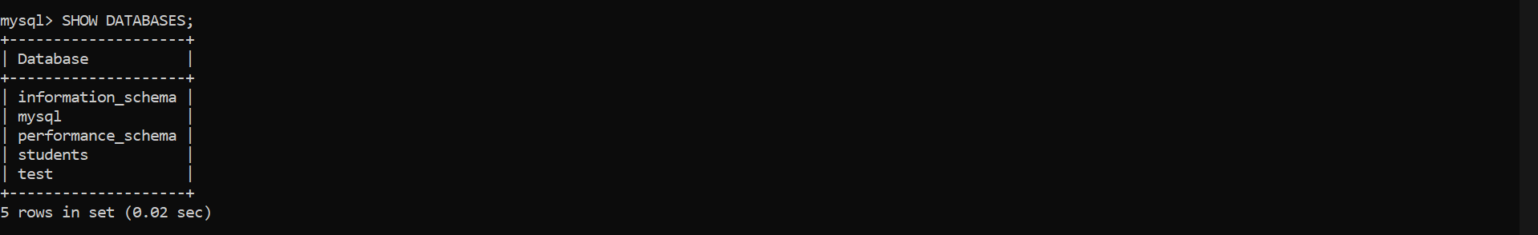

1. Creating a Table

Code: CREATE TABLE STUDENTS;

Output:



1. Viewing the Table

Code: DESC Students;

Output:

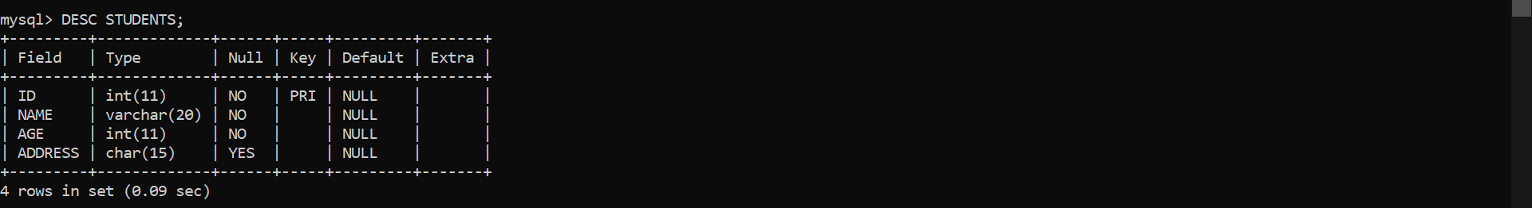

1. Inserting Records in the Table

Code: INSERT INTO STUDENTS

VALUES(1, ‘GAURANG’, 17, ‘KANDIVALI’),

(2, ‘MANOHAR’, 18, ‘MALAD’),

(3, ‘ASHMI’, 18, ‘KANDIVALI’),

(4, ‘DHANANJAY’, 18, ‘KANDIVALI’),

(5, ‘NEEL’, 17, ‘AHEMDABAD’);

Output:

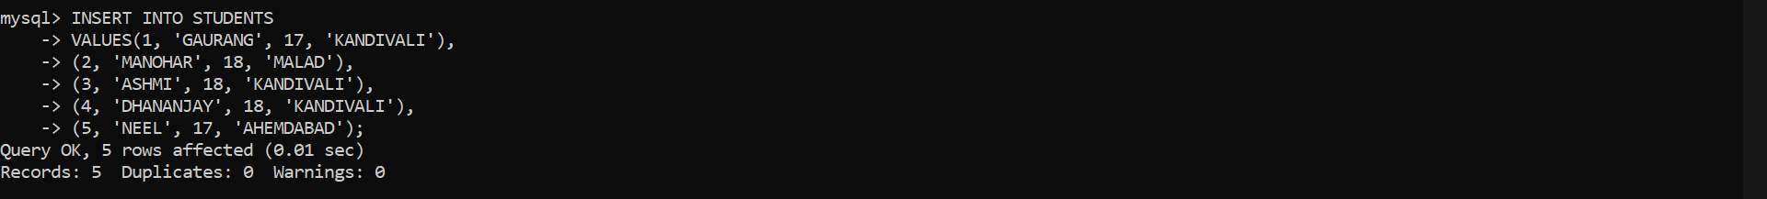

1. Viewing The Table(with constraints)

Code: SELECT \* FROM STUDENTS;

Output:

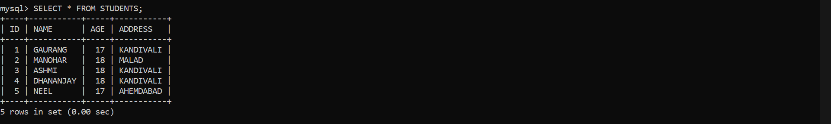

1. Update the Records in the table

Code: UPDATE STUDENTS

SET ADDRESS = ‘CHOTALIA’

WHERE ID = 5;

Output:



1. Deleting Record in a table

Code: DELETE FROM STUDENTS WHERE ID = 5;

Output:



1. Saving (Commit)

Code: COMMIT;

Output:



1. Undoing(Rollback)

Code: ROLLBACK;

Output:



Conclusion:

I have performed this practical creating database, table, & inserting, updating, deleting records & committing and rollbacking successfully.